1. True or False
   1. False |= True
      1. True
      2. Truth Table:

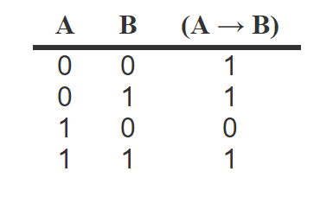

* 1. True |= False
     1. False
     2. Truth Table:



* 1. (A ^ B) |= (A ⇔ B)
     1. This is true because the left hand side has one model that is one of the two models of the right handed side
     2. Truth Table:

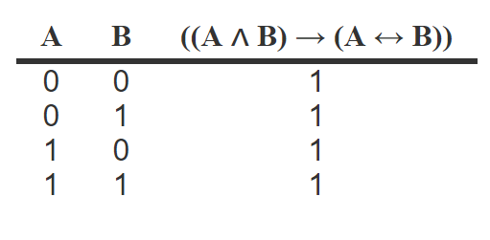

* 1. A ⇔ B |= A v B
     1. This is false, because one of the models of A ⇔ B has both A and B false, which does not satisfy AvB.
     2. Truth Table:

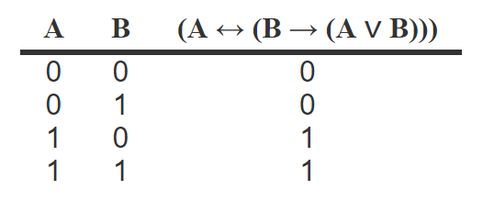

1. Is it valid?
   1. Smoke => Fire
      1. Smoke CAN mean that there is fire, but according to our implication, it is possible that there is smoke without fire, so this will be part of **NEITHER** truth table being:

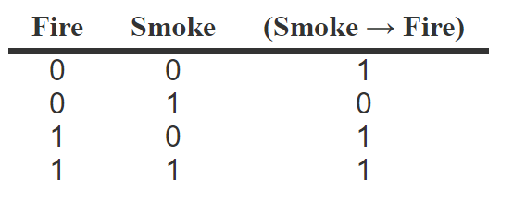

* 1. (smoke => Fire) => ((Smoke ^ Heat) => Fire)
     1. This logic always resolves to True, meaning that the given statement is **VALID**. Truth Table being:

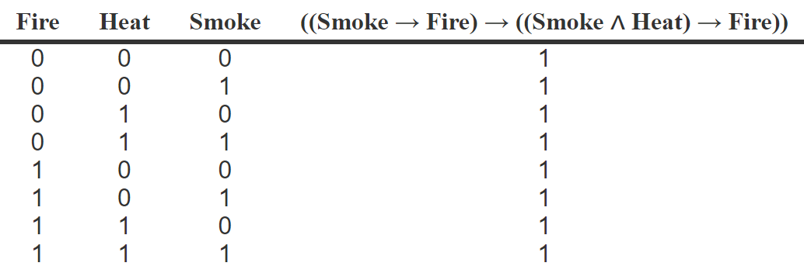

1. CNF
   1. Convert to CNF
      1. A⇔ (BvE)
         1. Clause 1(~A | B | E) Clause 2(~B | A) Clause 3 (~E | A)
      2. E=> D
         1. Clause 4 ~E | D
      3. C^F =>¬B
         1. Clause 5 ~C | ~F | ~B
      4. E=>B
         1. Clause 6 ~E | B
      5. B=>F
         1. Clause 7 ~B | F
      6. B=>C
         1. Clause 8 ~B | C
   2. Use resolution to prove ¬A ^ ¬B
      1. Clause 9 Add negation of what we want to prove: AvB
      2. Clause 10 Remove E from clause 1, using clause 6: ~AvB
      3. Clause 11 Remove f from clause 5 using clause 7: ~Cv~B
      4. Clause 12 Remove ~C from clause 11 with clause 8: ~B
      5. Clause 13 Remove B from clause 10 with clause 12: ~A
      6. Clause 14 B from clause 9 with clause 12: A

A^B is not a clause in this set, so ~A^~B is proven.